A Summer Training Project Report

on

BookVerse: Your All-In-One Library Hub

By: **Aryan Narayan** (12304518)

Under the guidance of

Prof. **Navnit Kumar (Techvanto Academy)**

From: **01/06/2024** To **15/07/2024**

Submitted to:



Department of Computer Science and Engineering

**Lovely Professional University**

**Punjab, India.**

**DECLARATION**

I hereby declare that I have completed my six weeks of summer training at **Techvanto Academy** from **10-June-2024** (start date) to **15-july-2024** (end date) under the guidance of

**Navnit Kumar sir** (Name of Industry coordinator). I declare that I have worked with full dedication during these six weeks of training and my learning outcomes fulfill the requirements of training for the award of the degree of Bachelor of Technology (Relevant Degree), Lovely Professional University,

Phagwara, India.

Name of Student: Aryan Narayan

Registration no: 12304518

Signature of student:

**Acknowledgment**

I would like to express my sincere gratitude to all those who have supported and guided me throughout the development of this project, BookVerse: Your All-In-One Library Hub.

Firstly, I would like to thank my supervisor, **Navnit sir**, for his continuous support, valuable feedback, and insightful guidance provided during the summer training program on Data Structures and Algorithms (DSA) at **Techvanto Academy**. His encouragement and expertise were instrumental in the successful completion of this project.

I am also grateful to **Techvanto Academy** for providing me with the opportunity to participate in the summer training program, which greatly enhanced my understanding of DSA and enabled me to develop this project.

A special thanks to my family and friends for their unwavering support and understanding during the development process. Their encouragement kept me motivated and focused.

Lastly, I would like to acknowledge the various online communities and resources that provided assistance and inspiration. The collaborative spirit and wealth of information available online were incredibly helpful in overcoming challenges and enhancing my understanding of various concepts.

Yours Faithfully,

Aryan Narayan

**Table of Contents**

|  |  |  |
| --- | --- | --- |
| **S. No.** | **Content** | **Page no.** |
| **1.** | **Cover Page** | **01** |
| **2.** | **Declaration Page** | **02** |
| **3.** | **Acknowledgment page** | **03** |
| **4.** | **Table of Contents** | **04** |
| **5.** | **Certificate** | **05** |
| **6.** | **Company Profile** | **06** |
| **7.** | **Introduction to Data Structures and Algorithms** | **07 - 14** |
| **8.** | **Introduction to BookVerse** | **15 -18** |
| 8.1 | Background | 15 |
| 8.2 | **Need for Automation** | 15 - 16 |
| 8.3 | Introduction **of "BookVerse"** | 16 – 17 |
| 8.4 | Motivation and Objective | 17 – 18 |
| 8.5 | Scope of the Project | 18 |
| **9.** | **Literature Review** | **19 - 20** |
| 9.1 | Traditional Library Management Systems | 19 |
| 9.2 | Modern Digital Library Management Systems | 19 |
| 9.3 | Case Studies of Existing Systems | 20 |
| 9.4 | Comparative Analysis | 20 |
| **10.** | **System Analysis** | **21 - 23** |
| 10.1 | Core Components | 21 |
| 10.2 | User Interactions | 22 |
| 10.3 | Workflow | 22 |
| 10.4 | Data Flow Diagram | 23 |
| **11.** | **Technology Stack** | **24** |
| **12.** | **Conclusion** | **25 - 26** |
| 12.1 | Achievements and Learning Outcomes | 25 |
| 12.2 | Project Impact | 25 |
| 12.3 | Future Enhancements | 26 |
| 12.4 | Final Thoughts | 26 |
| **13.** | **References** | **27 - 28** |

**Summer Training Certificate by Techvanto Academy**

|  |
| --- |
|  |

1. **Company Profile**



**Introduction:**

Techvanto Academy is a premier educational institution focused on providing high-quality training in the field of technology and engineering. Renowned for its comprehensive curriculum and experienced faculty, Techvanto Academy is dedicated to empowering students with the knowledge and skills necessary to excel in today's competitive technological landscape.

**Vision:**

Techvanto Academy envisions a world where education transcends traditional boundaries, enabling every individual to harness the power of technology for personal and professional growth. The academy strives to be a global leader in technology education, fostering innovation and excellence in every student.

**Origin:**

Founded by Ruthvik, Techvanto Academy is a testament to his vision and entrepreneurial spirit. Ruthvik co-founded the startup Techvanto Private Limited at the age of 22 and has since expanded operations to over four countries, serving more than 150 clients worldwide. The academy was established with the mission to bridge the gap between theoretical learning and practical application, recognizing the rapidly evolving tech industry.

**Goals:**

The primary goals of Techvanto Academy include:

1. Providing high-quality, accessible education in the field of technology.
2. Fostering a culture of continuous learning and innovation among students.
3. Bridging the gap between academia and industry through practical training and collaborations.
4. Empowering students to achieve their career aspirations and contribute to technological advancements.
5. Building a strong alumni community who can serve as mentors and role models for future students.
6. **Introduction to Data Structures and Algorithms**

**What are Data Structures?**

Data structures are specialized formats for organizing, processing, retrieving, and storing data. They are essential for managing large amounts of data efficiently, and they provide a means to handle data in a way that can optimize performance for various tasks.

**What are Algorithms?**

Algorithms are step-by-step procedures or formulas for solving problems. They are a set of rules or instructions given to an agent (such as a computer) to achieve a specific goal.

**Characteristics of Algorithms**

1. **Finite**: An algorithm must have a finite number of steps.
2. **Definite**: Each step of an algorithm must be precisely defined.
3. **Input**: An algorithm has zero or more inputs.
4. **Output**: An algorithm has one or more outputs.
5. **Effective**: An algorithm should be feasible with available resources.

**Importance of Data Structures and Algorithms**

1. **Efficiency**: Choosing the right data structure and algorithm can greatly improve the efficiency of a program in terms of time and space.
2. **Scalability**: Well-designed data structures and algorithms can handle large-scale data and complex problems more effectively.
3. **Optimization**: They help in optimizing code, making it faster and more efficient.
4. **Problem Solving**: Understanding data structures and algorithms is crucial for problem-solving in computer science and engineering.

**Types of Data Structures**

Data structures can be broadly classified into two categories: Linear and Non-Linear. Each category has its unique characteristics and is suitable for different types of applications.

1. **Linear Data Structures**

In linear data structures, data elements are arranged sequentially, This arrangement makes it easy to traverse the data in a single run. Example: Array, stack, queue, etc.

1. **Non-Linear Data Structure**

Elements are arranged in one-many, many-one and many-many dimensions.

Example: tree, graph, etc.

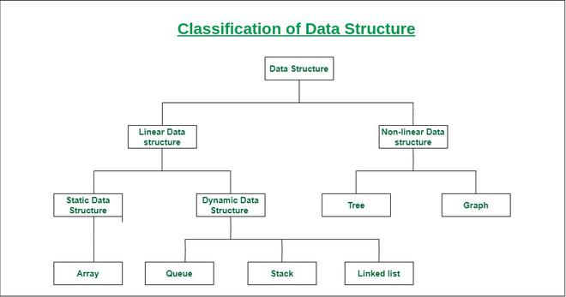**Types of Linear Data Structures:**

1. **Arrays**

* **Definition**: A collection of elements identified by index or key, where elements are of the same data type.
* **Characteristics**:
  + Fixed size.
  + Fast access to elements using index.
  + Insertion and deletion can be costly.
* **Use Cases**: Used in scenarios where quick access to elements is required, like in matrix operations and for storing data in a tabular form.

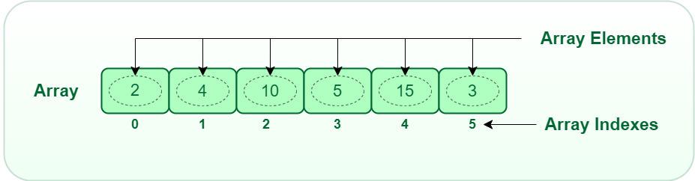

1. **Linked Lists**
2. **Definition**: A linear collection of elements called nodes, where each node points to the next node, forming a sequence.
3. **Types**:
   * **Singly Linked List**: Each node points to the next node.
   * **Doubly Linked List**: Each node points to both the next and the previous nodes.
   * **Circular Linked List**: The last node points back to the first node.
4. **Characteristics**:
   * Dynamic size.
   * Easy insertion and deletion.
   * Requires extra memory for storing pointers.
5. A diagram of a data flow

   Description automatically generated**Use Cases**: Useful in scenarios where frequent insertions and deletions are required, like in implementing stacks, queues, and graphs.
6. **Stacks**

* **Definition**: A collection of elements that follows the Last-In-First-Out (LIFO) principle.
* **Characteristics**:
  + Elements are added (pushed) and removed (popped) from the same end.
  + Supports operations like push, pop, and peek.
* **Use Cases**: Used in applications like function call management, expression evaluation, and backtracking algorithms.

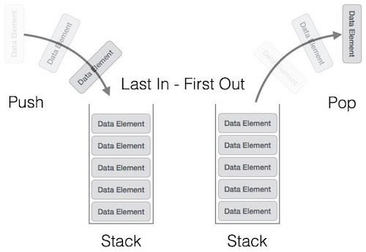

1. **Queues**

* **Definition**: A collection of elements that follows the First-In-First-Out (FIFO) principle.
* **Types**:
  + **Simple Queue**: Basic FIFO structure.
  + **Circular Queue**: The last position is connected back to the first position to make a circle.
  + **Priority Queue**: Elements are added with priority, and the highest priority elements are removed first.
* **Characteristics**:
  + Elements are added (enqueued) at the rear and removed (dequeued) from the front.
  + Supports operations like enqueue, dequeue, and peek.
* **Use Cases**: Used in scenarios like scheduling processes in operating systems, handling requests in web servers, and breadth-first search in graphs.

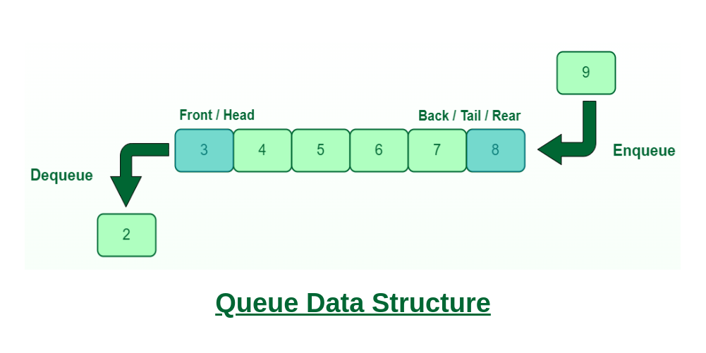

**Types of Non-Linear Data Structures:**

1. **Trees**
   * **Definition**: A hierarchical data structure with nodes, where each node has zero or more children nodes, and one root node.
   * **Types**:
     + **Binary Tree**: Each node has at most two children.

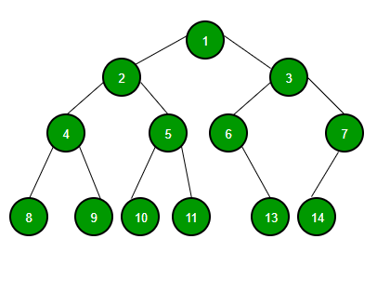

* + - **Binary Search Tree (BST)**: A binary tree with the property that left child values are less than the parent and right child values are greater than the parent.

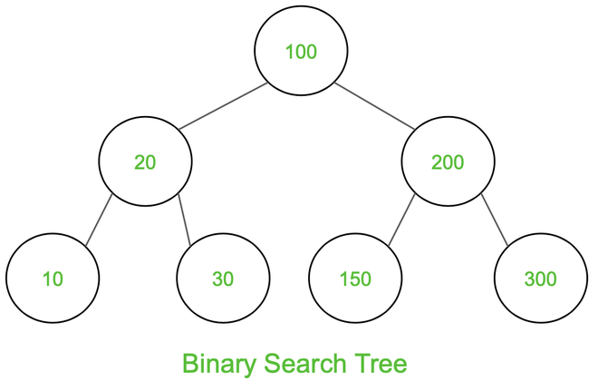

* + - **AVL Tree**: A self-balancing binary search tree.

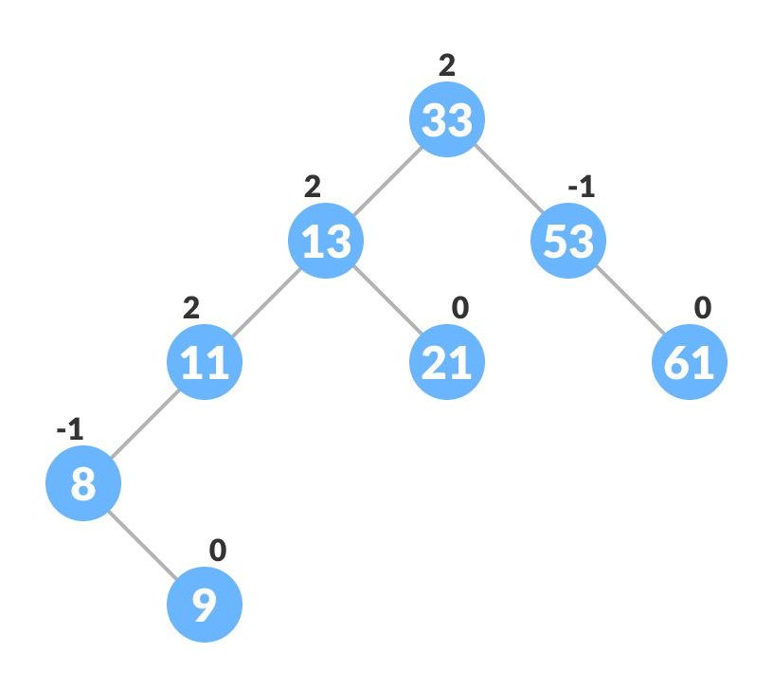

* + - **Heap**: A special tree-based structure that satisfies the heap property.

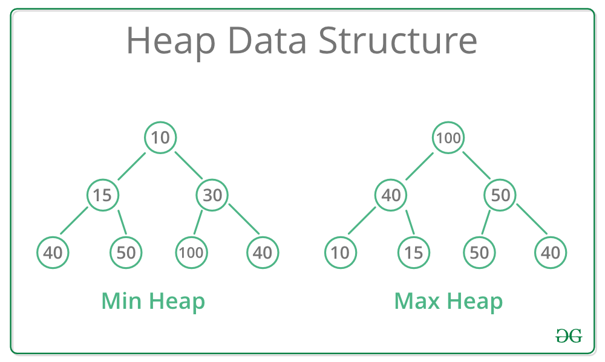

* + **Characteristics**:
    - Hierarchical structure.
    - Dynamic size.
    - Supports operations like insertion, deletion, and traversal.
  + **Use Cases**: Used in scenarios like hierarchical data representation, database indexing, and priority queues.

1. **Graphs**
   * **Definition**: A collection of nodes (vertices) and edges, where nodes represent entities and edges represent the connections between them.
   * **Types**:
     + **Undirected Graph**: Edges have no direction.
     + **Directed Graph (Digraph)**: Edges have a direction.

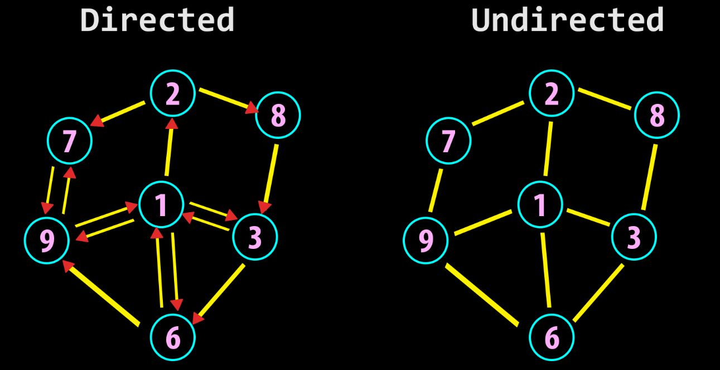

* + - **Weighted Graph**: Edges have weights or costs associated with them.
    - **Unweighted Graph**: Edges do not have weights.

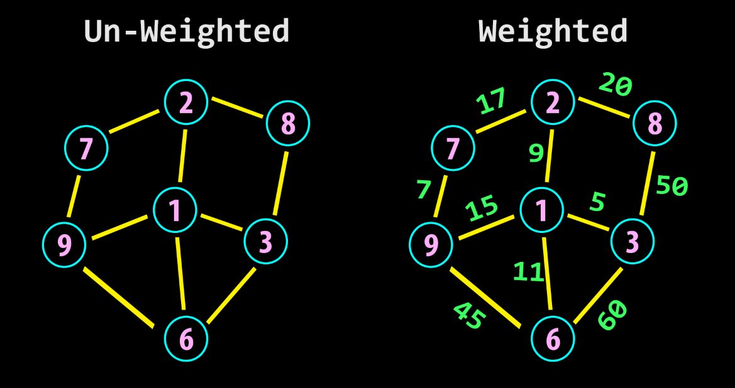

* + **Characteristics**:
    - Non-linear structure.
    - Can be cyclic or acyclic.
    - Supports operations like traversal, shortest path, and connectivity checks.
  + **Use Cases**: Used in scenarios like social network analysis, network routing, and solving puzzles like the traveling salesman problem.

**8. Introduction to BookVerse**

* 1. **Background**

The management of physical libraries often involves various manual processes that can be time-consuming and prone to errors. Traditional library systems rely on paper records and basic databases, making it challenging to track inventory, manage user accounts, and process transactions efficiently. As libraries grow, the need for an automated solution becomes increasingly important.

**Challenges in Traditional Library Management:**

1. **Inefficiency:** Manual record-keeping leads to delays in finding books, managing checkouts, and updating records.
2. **Data Loss:** Physical records are vulnerable to damage or loss, risking the entire library's inventory.
3. **Limited Accessibility:** Users may struggle to access information about available books or their borrowing history.
4. **Complexity in Management:** Tracking multiple users, books, and transactions can become overwhelming without a streamlined system.

**8.2** **Need for Automation**

To address these challenges, there is a growing need for automated library management systems that can provide:

* **Real-time Inventory Management:** Automating the tracking of book availability and condition, allowing librarians to manage collections effectively.
* **User-Friendly Interfaces:** Enabling users to search for and borrow books easily, enhancing their experience.
* **Efficient Data Processing:** Utilizing algorithms to handle large datasets for quick searches, sorting, and management tasks.

**8.3 Introduction of "BookVerse"**

"BookVerse" aims to solve these issues by providing an all-in-one solution for library management. By leveraging modern programming techniques and data structures, it simplifies operations, ensures data integrity, and enhances user interaction. This application is designed not only for efficiency but also for scalability, making it suitable for small to medium-sized libraries.

Through this project, we aim to demonstrate how technology can transform traditional library operations, making them more accessible and efficient for both librarians and users alike.

* 1. **Motivation and Objective**

**Motivation**

The primary motivation behind developing "BookVerse: Your All-In-One Library Hub" stems from the challenges and inefficiencies observed in traditional library management systems. The modern era demands more efficient, accurate, and user-friendly solutions to manage library operations. Several factors inspired the creation of this project:

1. **Increasing Library Collections:** As libraries grow, the sheer volume of books and materials makes manual cataloging and management impractical. The need for an automated system to efficiently manage large collections became evident.
2. **Technological Advancements:** With the rapid advancement in technology, there is an opportunity to leverage sophisticated algorithms and data structures to improve the performance and functionality of library management systems.
3. **User Expectations:** Modern users expect quick access to information. They want to search for books, check availability, and manage their accounts effortlessly. A digital system can meet these expectations by providing a seamless user experience.
4. **Administrative Efficiency:** Librarians and administrative staff need tools that can reduce their workload, minimize errors, and streamline processes such as book issuing, returning, and inventory management.
5. **Educational Purposes:** For students and professionals in computer science, developing a library management system offers a practical application of various data structures and algorithms, reinforcing theoretical knowledge with real-world practice.

**Objective**

The objective of the "BookVerse: Your All-In-One Library Hub" project is to design and implement a comprehensive, efficient, and user-friendly library management system that addresses the limitations of traditional methods. The specific goals include:

1. **Automation of Library Operations:** To automate key library operations such as cataloging books, issuing and returning books, and managing user accounts to enhance efficiency and accuracy.
2. **Efficient Data Management:** To utilize advanced data structures and algorithms to ensure quick and reliable performance for operations like searching, sorting, and updating records.
3. **User Accessibility:** To create an intuitive interface that allows users to easily search for books, check their availability, and manage their borrowing activities.
4. **Administrative Tools:** To provide librarians and administrators with robust tools for managing the library’s inventory, monitoring user activities, and generating reports.
5. **Scalability:** To develop a system that can scale to accommodate the needs of growing libraries, including an increasing number of books and users.

**Security:** To implement security measures that protect user data and ensure that only authorized users can perform certain actions, such as adding or deleting books.

* 1. **Scope of the Project**

The scope of the "BookVerse" project includes the following aspects:

1. **Book Management:**
   * **Addition of Books:** Admins can add new books to the system, including details such as ID, title, author, and quantity.
   * **Deletion of Books:** Admins can remove books from the system.
   * **Search Functionality:** Users can search for books by ID or title.
   * **Listing Books:** All books can be listed, sorted alphabetically by title for easy browsing.
2. **User Management:**
   * **User Registration:** Users can register with the system, creating accounts with a username and password.
   * **User Login and Logout:** Users can log in and out of the system, with authentication to ensure secure access.
   * **Admin and Regular Users:** Distinction between admin users, who have additional privileges (e.g., adding or deleting books), and regular users.
3. **Book Issuing and Returning:**
   * **Issuing Books:** Users can check out books, with the system tracking issued books and ensuring availability.
   * **Returning Books:** Users can return books, updating the system’s records to reflect the returned status.
4. **Data Structures and Algorithms:**
   * **Use of Efficient Data Structures:** Implementation of arrays, hash maps, and other data structures to manage and retrieve data efficiently.
   * **Sorting Algorithms:** Use of sorting algorithms to list books in a user-friendly manner.
5. **Security Features:**
   * **Authentication:** Secure login process to protect user accounts.
   * **Authorization:** Ensuring that only admins can perform certain actions, such as adding or deleting books.
6. **Testing:**
   * **Unit Testing:** Ensuring individual components of the system work as expected.
   * **Integration Testing:** Verifying that different components of the system interact correctly.
   * **System Testing:** Comprehensive testing to ensure the entire system meets the specified requirements.

**9. Literature Review**

The literature review for the "BookVerse: Your All-In-One Library Hub" project encompasses an examination of existing library management systems, the application of data structures and algorithms in such systems, and the evolution of digital library solutions. This review provides a foundation for understanding the current state of library management technologies and identifying areas for improvement.

* 1. **Traditional Library Management Systems**
  2. **Manual Systems:** Historically, libraries relied on manual processes for cataloging and tracking books. This included handwritten or typewritten records, card catalogs, and manual check-in/check-out procedures. While these systems were sufficient for small libraries, they became cumbersome and error-prone as collections grew.
  3. **Early Digital Systems:** With the advent of computers, libraries began adopting digital cataloging systems. These early systems, often built using basic database management software, improved accuracy and retrieval speed but were limited in functionality and scalability.
  4. **Modern Digital Library Management Systems**

**Integrated Library Systems (ILS):** Modern ILS, such as Koha, Evergreen, and Alma, provide comprehensive solutions for managing library operations. These systems integrate various functions, including cataloging, circulation, acquisitions, and user management. They leverage relational databases and offer web-based interfaces for ease of access.

**Features of ILS:**

* **Cataloging:** Automated entry and classification of books and materials.
* **Circulation:** Tracking of issued and returned books.
* **User Management:** Managing user accounts and borrowing histories.
* **Search and Discovery:** Advanced search functionalities to help users find books quickly.
* **Reporting:** Generating reports for inventory management and decision-making.
  1. **Case Studies of Existing Systems**

1. **Koha:** An open-source ILS widely adopted by libraries worldwide. Koha offers modules for cataloging, circulation, acquisition, and serial management. It supports MARC (Machine-Readable Cataloging) standards and provides a web-based interface for both users and administrators.
2. **Evergreen:** Another open-source ILS, Evergreen is known for its scalability and robustness. It supports large consortia of libraries, providing shared catalogs and resource sharing capabilities.
3. **Alma:** A cloud-based ILS by Ex Libris, Alma integrates with other library solutions such as Primo for discovery and Leganto for reading lists. It supports complex workflows and extensive reporting features.

#### **Comparative Analysis**

1. **Strengths:**
   * **Comprehensive Functionality:** Modern ILS offer a wide range of features, making them suitable for large and diverse library collections.
   * **User-Friendly Interfaces:** Web-based interfaces and intuitive designs enhance user experience.
   * **Scalability:** Systems like Evergreen are designed to handle large volumes of data and users.
2. **Weaknesses:**
   * **Complexity:** The extensive features and functionalities can make these systems complex to set up and manage, requiring specialized knowledge.
   * **Cost:** While open-source systems reduce licensing costs, the implementation and maintenance can still be expensive.
   * **Customization:** Customizing these systems to meet specific needs can be challenging and may require significant technical expertise.

**10. System Analysis**

System analysis involves breaking down the project into its core components and understanding the interactions between these components. For "BookVerse: Your All-In-One Library Hub," we focus on user requirements, functionalities, and system components.

#### **Core Components**

1. **Book Class:**
   * **Attributes:**
     + id: Unique identifier for each book.
     + title: Title of the book.
     + author: Author of the book.
     + quantity: Total number of copies available.
     + issuedCount: Number of copies currently issued.
   * **Methods:**
     + isAvailable(): Checks if the book is available for issuing.
2. **User Class:**
   * **Attributes:**
     + username: Unique identifier for the user.
     + password: Password for user authentication.
     + isAdmin: Boolean flag indicating if the user is an admin.
3. **Library Class:**
   * **Attributes:**
     + books: List of all books in the library.
     + users: Map of all registered users.
     + currentUser: The user currently logged in.
   * **Methods:**
     + registerUser(): Registers a new user.
     + loginUser(): Authenticates a user and logs them in.
     + logoutUser(): Logs out the current user.
     + isAdmin(): Checks if the current user is an admin.
     + findBookIndexById(): Finds the index of a book by its ID.
     + addBook(): Adds a new book (admin only).
     + searchBookById(): Searches for a book by its ID.
     + searchBookByTitle(): Searches for a book by its title.
     + issueBook(): Issues a book to a user.
     + returnBook(): Returns a book.
     + listAllBooks(): Lists all books sorted by title.
     + deleteBook(): Deletes a book by its ID.
     + displayBookDetails(): Displays details of a book.

#### **User Interactions**

1. **Admin Users:**
   * Can add, delete, and list all books.
   * Can register new users.
   * Have all privileges of regular users.
2. **Regular Users:**
   * Can search for books by ID or title.
   * Can issue and return books.
   * Can view book details and availability.

#### **Workflow**

1. **Registration:**
   * Users register with a username, password, and admin status.
   * Registration data is stored in the users map.
2. **Login/Logout:**
   * Users log in using their username and password.
   * The system authenticates the credentials and sets the currentUser.
   * Users can log out, which clears the currentUser.
3. **Book Management:**
   * Admins can add new books by providing details like ID, title, author, and quantity.
   * Books are stored in the books list.
4. **Searching:**
   * Users can search for books by ID or title.
   * The system finds the book and displays its details.
5. **Issuing/Returning:**
   * Users can issue books if available.
   * Issued books increment the issuedCount.
   * Users can return books, which decrements the issuedCount.
6. **Listing/Deleting:**
   * Admins can list all books sorted by title.
   * Admins can delete books by ID.

#### **Data Flow Diagram**

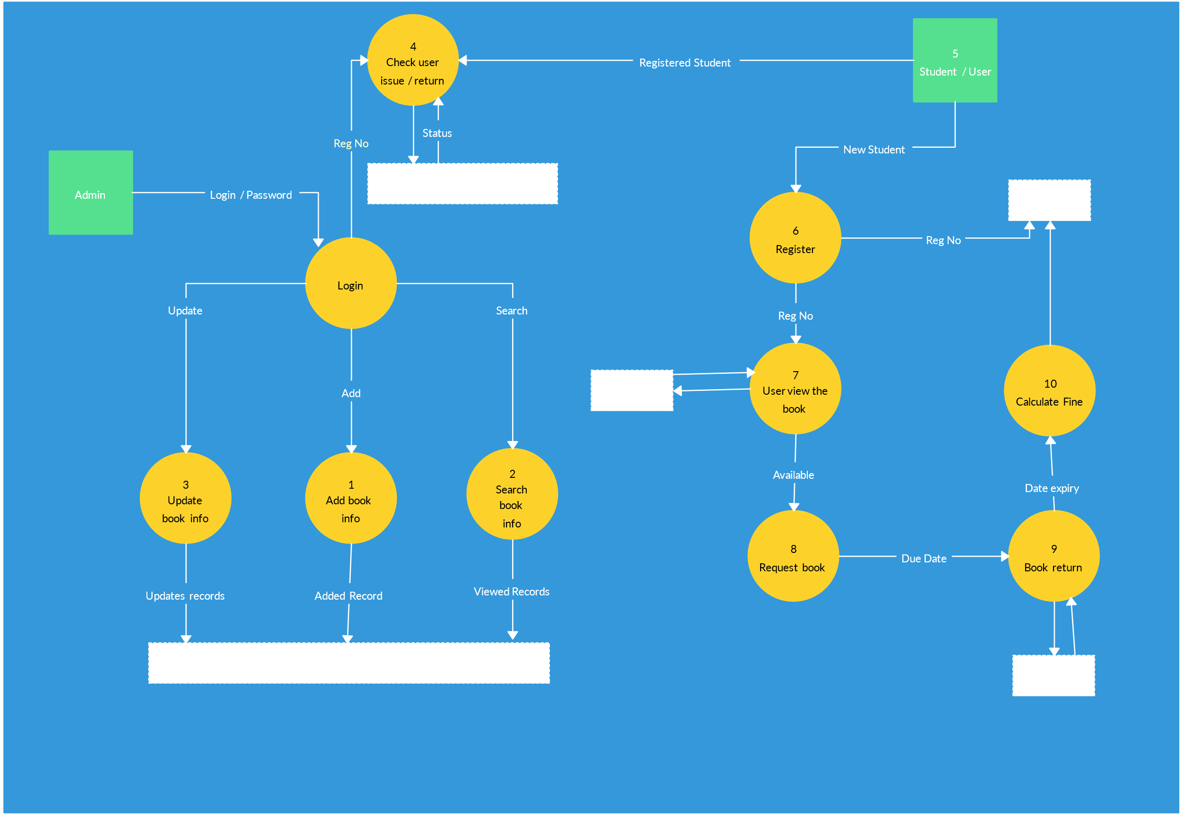

**11. Technology Stack**

The technology stack refers to the set of tools and technologies used to build the "BookVerse: Your All-In-One Library Hub" project. Here's a simple breakdown:

#### **11.1 Programming Language**

* **Java**: We used Java to write the entire application. It's a powerful language that's good for building robust and reliable software. Java also has a lot of libraries that make coding easier.

#### **11.2 Data Structures**

* **ArrayList**: This is like a flexible array that can grow as needed. We used it to store the list of books in the library.
* **HashMap**: This is a data structure that allows us to quickly find information using a key. We used it to store user information (like usernames and passwords) so we can quickly check if a user is registered or not.

#### **11.3 Integrated Development Environment (IDE)**

* **Visual Studio Code (VS Code)**: This is a lightweight and powerful code editor. It helps us write and test our code efficiently. It has many extensions that support Java development, making it a great tool for our project.

#### **11.4 Version Control**

* **Git**: This tool helps us keep track of changes to our code. It allows us to go back to earlier versions if something goes wrong.
* **GitHub**: This is an online service where we store our code. It makes it easy to collaborate with others and keep our code safe.

By using these tools and technologies, we made the development process easier, more organized, and more efficient. The stack ensures that "BookVerse" is well-built and reliable, making it a solid library management system.

**12. Conclusion**

The "BookVerse: Your All-In-One Library Hub" project has been a comprehensive and educational endeavor, demonstrating the practical application of various Data Structures and Algorithms (DSA) concepts within a real-world context. Here are the key takeaways and final thoughts on the project:

#### **Achievements and Learning Outcomes**

1. **Understanding DSA**: One of the primary objectives of this project was to deepen our understanding of essential DSA concepts, such as arrays, linked lists, stacks, queues, strings, binary trees, binary search trees, graphs, dynamic programming, sorting, and hashing. Implementing these in the project provided practical experience and a stronger grasp of theoretical knowledge.
2. **Problem-Solving Skills**: Developing this project required solving numerous small and large problems, from designing efficient algorithms to debugging issues. This has significantly enhanced our problem-solving skills and ability to think algorithmically.
3. **Software Development Lifecycle**: The project followed a structured software development lifecycle, including system analysis, design, implementation, testing, and deployment. This holistic approach has provided valuable insights into managing a software project from start to finish.
4. **Collaboration and Tools**: Utilizing tools such as Visual Studio Code for coding, Git, and GitHub for version control build management highlighted the importance of using the right tools for software development. These tools facilitated collaboration, code management, and project organization.

#### **Project Impact**

1. **Efficiency in Library Management**: The "BookVerse" system significantly improves library management efficiency by automating tasks such as book addition, search, issue, return, and deletion. This reduces manual effort, minimizes errors, and enhances the overall user experience for both admin and regular users.
2. **User-Friendly Interface**: The command-line interface developed for the project ensures that users can easily interact with the system, whether they are admins managing the library or students looking for books. The straightforward design ensures usability and accessibility.
3. **Scalability and Flexibility**: The project is designed to be scalable and flexible. New features can be easily added, and the system can handle an increasing number of books and users without performance degradation. This ensures that the library management system can grow and adapt to future needs.

#### **Future Enhancements**

While the project has achieved its primary goals, there are several areas for potential future enhancements:

1. **Graphical User Interface (GUI)**: Implementing a GUI would make the system more user-friendly and visually appealing. This could involve developing a web or desktop application with an intuitive interface.
2. **Advanced Search and Filters**: Enhancing the search functionality with advanced filters (e.g., by genre, publication date) would improve user experience. Implementing a fuzzy search could also help users find books with partial or misspelled titles.
3. **Integration with External Systems**: Integrating the system with external databases or library networks could provide additional features, such as accessing books from other libraries or digital repositories.
4. **Mobile Application**: Developing a mobile application version of the system would increase accessibility, allowing users to manage and access the library on the go.
5. **Data Analytics**: Implementing data analytics could provide valuable insights into book usage patterns, user preferences, and library trends. This data could help in making informed decisions about library management and resource allocation.

#### **Final Thoughts**

The "BookVerse: Your All-In-One Library Hub" project has been a significant learning experience, combining theoretical knowledge with practical application. The project has not only enhanced our technical skills but also provided a deeper understanding of software development processes. We believe that with continuous improvements and enhancements, this project can serve as a robust solution for library management, benefiting both administrators and users alike.

This project demonstrates the potential of combining technology with traditional library management to create a more efficient, user-friendly, and scalable system. The knowledge and experience gained from this project will undoubtedly be valuable in future software development endeavors.

**13. References**

• **LPU Logo**:

* Source: LPU logo image
* URL: [LPU logo](https://encrypted-tbn0.gstatic.com/images?q=tbn:ANd9GcRDsmvvX6LeBChnL86_bJbHbfBIVL1vkjI62Q&s)

• **Techvanto Academy Logo**:

* Source: Techvanto Academy logo image
* URL: [Techvanto Academy logo](https://pbs.twimg.com/profile_images/1364105637542600706/iovNIAaF_400x400.jpg)

• **Data Structure Types**:

* Source: Image showing different data structure types
* URL: [Data structure type](https://encrypted-tbn0.gstatic.com/images?q=tbn:ANd9GcT14EQuXI7V49zpSMe_8M5-CJyopcZ83JAXEA&s)

• **Array Diagram**:

* Source: Diagram explaining arrays
* URL: [Array Diagram](https://media.geeksforgeeks.org/wp-content/uploads/20220721080308/array.png)

• **LinkedList Diagram**:

* Source: Diagram explaining linked lists
* URL: [LinkedList Diagram](https://media.geeksforgeeks.org/wp-content/uploads/20220712172013/Singlelinkedlist.png)

• **Stack Diagram**:

* Source: Diagram explaining stacks
* URL: [Stack Diagram](https://www.tutorialspoint.com/data_structures_algorithms/images/stack_representation.jpg)

• **Queue Diagram**:

* Source: Diagram explaining queues
* URL: [Queue Diagram](https://encrypted-tbn0.gstatic.com/images?q=tbn:ANd9GcTz-5tvNlSpkfCIEBlnKblcpbEtXRK2iY4gwg&s)

• **Tree Diagram**:

* Source: Diagram explaining trees
* URL: [Tree Diagram](https://media.geeksforgeeks.org/wp-content/cdn-uploads/binary-tree-to-DLL.png)

• **Binary Search Tree (BST) Diagram**:

* Source: Diagram explaining binary search trees
* URL: [BST diagram](https://media.geeksforgeeks.org/wp-content/cdn-uploads/20221215114732/bst-21.png)

• **AVL Tree Diagram**:

* Source: Diagram explaining AVL trees
* URL: [AVL tree diagram](https://www.programiz.com/sites/tutorial2program/files/avl-tree_update-bf.png)

• **Heap Data Structure**:

* Source: Diagram explaining heap data structures
* URL: [Heap data structure](https://media.geeksforgeeks.org/wp-content/cdn-uploads/20221220165711/MinHeapAndMaxHeap1.png)

• **Graphs**:

* Source 1: Diagram explaining directed vs undirected graphs
* URL: [Graphs - directed vs undirected](https://simplesnippets.tech/wp-content/uploads/2021/10/directed-vs-undirected-graph-data-structure.jpg)
* Source 2: Diagram explaining weighted vs unweighted graphs
* URL: [Graphs - weighted vs unweighted](https://simplesnippets.tech/wp-content/uploads/2021/10/weighted-vs-uweighted-graph-data-structure.jpg)

• **DFD Diagram**:

* Source: Data Flow Diagram (DFD)
* URL: [DFD Diagram](https://svg.template.creately.com/io7f2y7y)